**Materials**

Classification of Engineering Materials

Generally, engineering materials are classified into four types viz. Metals and alloys, ceramics and glasses, polymers, and composites. Let’s have a look at them.

|  |
| --- |
|  |
| Classification of Engineering Materials |

## **Classification of Engineering Materials**

* Metals and Alloys
* Ceramics and glasses
* Polymers
* Composites

### Metals and Alloys

Inorganic materials are composed of one or more metallic elements.

* They usually have crystalline structures and are good thermal and electrical conductors.
* They maintain their good strength at high and low temperatures.
* Many metals have high elastic strength and high elastic modulus.
* They are the least resistant to corrosion.
* They have sufficient ductility.
* One more important characteristic, they can be strengthened by alloying and heat treatment.

### Ceramics and Glasses

Inorganic materials consisting of both metallic and non-metallic materials bonded together chemically.

* They can be crystalline (ceramics), non-crystalline (glasses), or a mixture of both (glasses and ceramics).
* They have high hardness, high moduli, and high-temperature strength.
* Since they are brittle, they cannot be used as good as metals.
* Generally, they have a high melting point and high chemical stability.
* Ceramics are generally poor conductors of electricity.
* Ceramics have high strength on compression.

### Polymers

Organic materials consist of long molecular chains or networks containing carbon.

* They generally have low densities and low rigidity.
* Their mechanical properties may vary considerably.
* Most polymers are non-crystalline but some consist of a mixture of both crystalline and non-crystalline regions.
* Most of them are corrosion resistant, but they cannot be used at high temperatures.
* Most of them are poor conductors of electricity due to the nature of atomic bonding.
* They generally have good strength to weight ratio.

### Composites

Materials where two or more of the above materials are brought together on a macroscopic level.

* They are designed to combine the best properties of each of its components.
* Usually, they consist of a matrix and a reinforcement.

**Ceramic Materials**

\ **Ceramic materials are non-metallic solids. These are made of inorganic compounds such as Oxides, Nitrides, Silicates and Carbides. Ceramic materials possess exceptional Structural, Electrical, Magnetic, Chemical and Thermal properties. These ceramic materials are now extensively used in different engineering fields. Examples: Silica, glass, cement, concrete, garnet, Mgo, Cds, Zno, SiC etc.**

**Organic Materials**

#### **All organic materials are having carbon as a common element. In organic materials carbon is chemically combined with oxygen, hydrogen and other non-metallic substances. Generally organic materials are having complex chemical bonding. Example: Plastics, PVC, Synthetic Rubbers etc**.

#### **Metals**

Metals are polycrystalline bodies which are having number of differentially oriented fine crystals. Normally major metals are in solid states at normal temperature. However, some metals such as mercury are also in liquid state at normal temperature. All metals are having high thermal and electrical conductivity. All metals are having positive temperature coefficient of resistance. Means resistance of metals increases with increase in temperature.

Examples of metals – Silver, Copper, Gold, Aluminum, Iron, Zinc, Lead, Tin etc. Metals can be further divided into two groups-

* **1. Ferrous Metals –**All ferrous metals are having iron as common element. All ferrous materials are having very high permeability which makes these materials suitable for construction of core of electrical machines. Examples: Cast Iron, Wrought Iron, Steel, Silicon Steel, High Speed Steel, Spring Steel etc.
* **2. Non-Ferrous Metals -** All non-ferrous metals are having very low permeability. Example: Silver, Copper, Gold, Aluminum etc.

#### **Non-Metals**

Non-Metal materials are non-crystalline in nature. These exists in amorphic or mesomorphic forms. These are available in both solid and gaseous forms at normal temperature. Normally all non-metals are bad conductor of heat and electricity. Examples: Plastics, Rubber, Leathers, Asbestos etc. As these non-metals are having very high resistivity which

**Composition of Mild Steel –**  
  
Carbon steels are alloy of pure iron and carbon. Depending upon the percentage of carbon, they can be classified as –  
  
(i) Low carbon (or mild) steel - 0.05-0.3% C  
 (a) Dead mild steel -0.05-0.15% C  
 (b) Mild steel - 0.15-0.2% C  
 (c) Mild steel - 0.2-0.3% C  
(ii) Medium carbon steel - 0.3-0.6% C  
(iii) High carbon steel - 0.6-1.5% C  
A special type of high carbon steel containing 0.9-1.5% C is known as tool steel, used for making tools of various machines.

**Properties of Mild Steel –** Various properties of mild steel are given as follows -  
  
(i) It can be easily forged and welded.  
(ii) It can be magnetized permanently.  
(iii) It has fibrous structure.  
(iv) It cannot be hardened and tempered easily.  
(v) It cannot be easily affected by hard water.  
(vi) It is ductile and malleable.  
(vii) It rusts readily  
(viii) Its ultimate compressive strength is about 80 to 120 kN/cm2.  
(ix) Its specific gravity is 7.80.  
(x) It is tougher and more elastic than wrought iron.  
(xi) Its ultimate tensile and shear strengths are about 60 to 80 kN/cm2.  
(xii) Its melting point is about 1390°C.  
  
**Uses of Mild Steel –**The uses of mild steel are as follows –  
  
(i) Mild steel containing 0.05 to 0.15% carbon is used for making stampings, wires, rivets, sheets, screws, pipes, thin plates, automobile body, nails and chain.  
  
(ii) Mild steel containing 0.15 to 0.20% carbon has a tensile strength of 420 MPa, is used for making camshafts, sheets and strips for fan blades, universal beams, welded tubing, forgings, drag lines, etc.  
  
(iii) Mild steel containing 0.20 to 0.30% carbon has a tensile strength of 555 MPa and hardness of 140 BHN. It is used for making gears, valves, connecting rods, crankshafts, railway axles, fish plates, small forgings, etc.  
  
**Medium carbon steel contains carbon from 0.3 to 0.60%.**  
  
Steel containing 0.3-0.45% carbon has tensile strength of 750 N/mm2. They have good machinability and good deep hardening properties. They are used for making axles, heavy duty shafts, connecting rods, rails, turbine discs, rotor and gear shafts, etc.  
  
Steel containing 0.45-0.55% carbon has tensile strength of 1000 N/mm2 and are used for manufacturing parts which have to be subjected to shock and heavy reversal of stress, such as railway coach axles, large size forgings such as crankshafts, gear axles, spline shafts, etc.  
  
Steel containing 0.55-0.60% carbon are used for making drop forging dies, die blocks, plate punch, self tapping screws, valve springs, cushion springs, lock washers, thrust washers, etc.  
  
Steel containing 0.60 to 1.5% carbon is known as high carbon steel. They possess wear resistance and high hardness after heat treatment.  
  
**Chemical composition of high carbon steel is given as follows –**

|  |  |
| --- | --- |
| Material | Percentage |
| Carbon | 0.6-1.5 |
| Silicon | 0.15-0.3 |
| Manganese | 0.15-0.35 |
| Chromium | 0.2 |

**Properties -** Various properties of high carbon steel are given as follows-  
  
(i) Its ultimate tensile strength is about 80 to 110 kN/cm2 .  
(ii) Its ultimate shear strength is about 110 kN/cm2.  
(iii) Its ultimate compressive strength is about 140 to 200 kN/cm2.  
(iv) Its specific gravity is 7.90.  
(v) It can be easily tempered and hardened.  
(vi) It can be magnetized permanently.  
(vii) It can be easily forged and welded.  
(viii) It rusts easily and rapidly.  
(ix) It is tougher and more elastic than mild steel.  
(x) It has granular structure.  
(xi) It cannot be easily affected by salt water.  
  
**Uses –** Uses of high carbon steel are given as follows –  
  
(i) Steels containing 0.6 to 0.8% carbon are used for making cold chisels, wrenches, automatic clutch discs, etc.  
  
(ii) Steels containing 0.8 to 0.9% carbon are used for making rock drills, punches, dies, railway rails, circular saws, machine chisels ,etc.  
  
(iii) Steels containing 0.9 to 1.0 % carbon are used for making springs, keys, pins, etc.  
  
(iv) Steels containing 1.0 to 1.1% carbon are used for making machine tools, mandrels, taps, etc.  
  
(v) Steels containing 1.1 to 1.5% carbon are used for making twist drills, taps, thread metal dies, knives, etc.

**alloy steels their application**

## What is Alloy Steel?

Alloy steel has been alloyed with other elements, ranging from 1 to 50 weight percent, in addition to carbon, to improve the material's various qualities. Various types of alloy steel are being produced today, such as High-strength low alloy (HSLA) steel, Stainless steel, Microalloyed steel, etc.

Steel Alloy Composition - These substances frequently contain boron, silicon, manganese, nickel, chromium, molybdenum, vanadium, and nickel. Less common elements include aluminum, cobalt, copper, cerium, niobium, titanium, tungsten, lead, zinc, and zirconium.

For example, stainless steel is an alloy ofp for Free Mock Test

* iron,
* chromium and
* nickel( in some cases) and other metals.

## Types of Alloy Steel

Steel is mostly made of iron, comparable in hardness to pure copper. Like all other metals, iron is polycrystalline, which means that its crystals are joined at their boundaries, except a few extreme cases. Alloy steel is divided into several subcategories. These consist of:

* Low-alloy steel
* High-strength low alloy (HSLA) steel
* High-alloy steel
* Stainless steel
* Microalloyed steel
* Advanced high-strength steel (AHSS)
* Maraging steel
* Tool steel

## Steel Alloy Properties

Alloy steels can contain various elements, each of which can improve the material's resistance to corrosion, heat, and mechanical stress. While higher additions of up to 20 wt.% boost corrosion resistance and stability at high or low temperatures, smaller additions of less than 5 wt.% tend to improve mechanical qualities, such as hardenability and strength.

## Production & Processing of Alloy Steel

The desired outcome determines the procedures for alloying and processing alloy steel. The necessary mixture of components is first fused for eight to twelve hours at temperatures above 1600°C. After that, the steel is annealed at more than 500 °C to remove impurities and modify its chemical and physical properties.

Before repeating the annealing and descaling procedure, the mill scale (a combination of iron oxides), a by-product of the annealing process, is first cleaned from the surface of the steel with hydrofluoric acid. The steel is finally melted and cast before being rolled and shaped into its final form.

## Applications & Examples of Alloy Steel

Since "alloy steel" refers to various steel types, its application varies. Due to their extreme strength, machinability, affordability, and availability, low alloy steels are used in various industries. They can be found in ships, pipelines, pressure vessels, oil drilling platforms, military vehicles, construction equipment, and structural elements. HY80 and HY100 are two examples.

High-alloy steels can be expensive to produce and challenging to work with. However, they are perfect for structural components, automotive applications, chemical processing, and power generation equipment due to their high hardness, toughness, and corrosion resistance. The grades HE, HF, HH, HI, HK, and HL are a few examples of high-alloy steels

**Engineering Properties of Materials: Define Mechanical Properties**

**The Mechanical properties of engineering materials** are those of the material that comes into action on applying forces. A substance (often a solid) is characterized as material if it is meant to be utilized for a certain purpose. We are surrounded by a wide variety of materials used in everything from spacecraft to structures. Engineering Materials are substances employed as raw materials for construction or organized production for an engineering application. Materials are classified according to their characteristics. They possess qualities such as magnetism, thermal conductivity, heat capacity, stiffness, hardness, and thermal conductivity, among others. Among various materials, the Mechanical properties of engineering materials tell the material's response against applied load.

The Mechanical properties of engineering materials can be used as a standard to compare the advantages of various materials, assisting in the choice of materials. So a good knowledge of the Mechanical properties of engineering materials is very important for selecting materials for a particular application. Material selection is deciding which materials will be utilized for a certain application.

## What are the Mechanical Properties of Engineering Materials?

Understanding the material's mechanical properties is crucial before choosing it for a particular engineering product or application. "**The Mechanical properties of engineering materials are those that influence their mechanical strength and capacity for shaping into a desired shape**." Or in other words, "**Mechanical properties are physical properties that a material exhibits upon the application of forces.**"

Everything we use daily may be modified to work in particular situations. This can be done effectively if we know each material's characteristics beforehand. Significant materials' properties have been tested to classify them into broad groupings. Product designers can use the information from a description of some typical mechanical and physical properties to help them choose the right materials for a particular application.

## Important Mechanical Properties of Engineering Materials

A material's property is an intensive attribute of some material and independent of the material's quantity. Some important Mechanical properties of engineering materials are:

* Strength
* Hardness
* Toughness
* Brittleness
* Ductility
* Malleability

### Strength

A material's ability to resist deformation or breakdown in the presence of loads or external forces is known as strength. The materials we choose for our engineering goods must be sufficiently strong mechanically to function under various mechanical forces or loads.

### Hardness

Hardness is one of the important properties among the mechanical properties of engineering materials which enables the material to offer resistance to localized permanent deformation and scratches. Numerous applications of engineering design make use of hardness. This characteristic is crucial since it directly affects the functionality and appropriateness of the material.

### Toughness

A material's ability to absorb energy and undergo plastic deformation without fracturing is known as toughness. The amount of energy in a given volume determines its numerical value. Joules/m3 is the unit of toughness. Stress-strain properties of a material can be used to calculate a material's toughness value. Materials need to be strong and ductile to be tough. Impact testing equipment is used to determine a metal's toughness.

### Brittleness

A material's brittleness refers to how easily it fractures under the influence of a force or load. When brittle material is stressed, it experiences very little energy and cracks without experiencing a lot of strain. The opposite of a material's ductility is brittleness. Material brittleness is temperature-dependent. Some metals that are ductile at room temperature become brittle at low temperatures.

### Ductility

A solid material's ductility is a property that describes how easily it deforms when subjected to tensile stress. The capacity of a substance to be drawn or pulled into a wire is a common way to classify ductility. This mechanical quality, which is temperature-dependent, is also a component of a material's plasticity. The ductility of a substance increases with temperature.

### Malleability

A solid material's malleability refers to how quickly it can distort when subjected to compressive stress. The ability of a material to be rolled or hammered into a thin sheet is a common way to classify malleability. This mechanical quality is a component of the material's plasticity. Temperature affects a material's malleability. The malleability of the material rises as the temperature rises.

Creep, hardenability, resilience, and fatigue are additional essential mechanical properties of engineering materials in addition to the ones described above.

**Tensile test- Stress-strain diagram of ductile and brittle materials**

Watch this video

<https://www.youtube.com/watch?v=PscKEiT2K8U>

# Hooke's Law

In the 19th-century, while studying springs and elasticity, English scientist Robert Hooke noticed that many materials exhibited a similar property when the stress-strain relationship was studied. There was a linear region where the force required to stretch the material was proportional to the extension of the material. This is known as Hooke’s Law. In this article, let us learn about Hooke’s law in detail.

## **What is Hooke’s Law?**

Stress and strain take different forms in different situations. Generally, for small deformations, the stress and strain are proportional to each other, and this is known as Hooke’s Law.

Hooke’s law states that the strain of the material is proportional to the applied stress within the elastic limit of that material.

When the [elastic materials](https://byjus.com/physics/elastic-behaviour-of-materials/) are stretched, the atoms and molecules deform until stress is applied, and when the stress is removed, they return to their initial state.

Mathematically, Hooke’s law is expressed as:

*F* = –*kx*

In the equation, *F* is the force, *x* is the extension in length, *k* is the constant of proportionality known as the spring constant in N/m.

### **Hooke’s Law Experiment**

Consider a spring with load application, as shown in the figure.

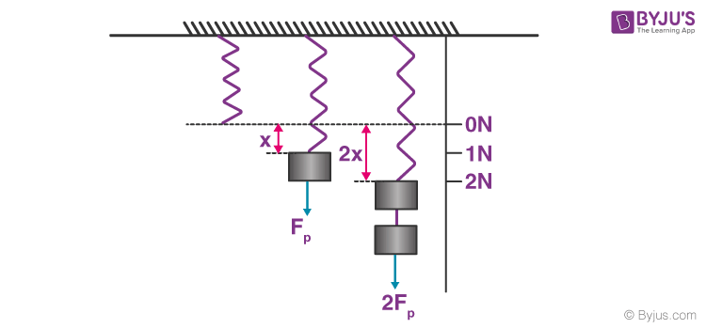

*The figure shows the stable condition of the spring when no load is applied, the condition of the spring when elongated to an amount x under the load of 1 N, the condition of the spring elongated to 2x under the influence of load 2 N.*

Depending on the material, different springs will have different spring constants, which can be calculated. The figure shows us three instances, the stable condition of the spring, the spring elongated to an amount x under a load of 1 N, and the spring elongated to 2x under a load of 2 N. If we substitute these values in the Hooke’s law equation, we get the spring constant for the material in consideration.

### **Hooke’s Law Graph**

The figure below shows the stress-strain curve for low carbon steel.

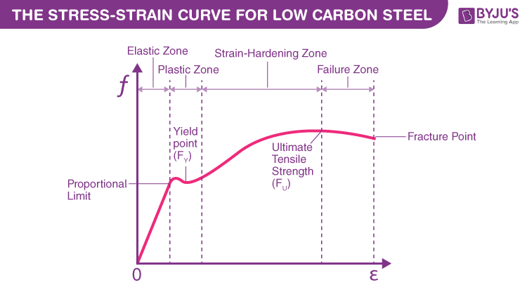

*The material exhibits elastic behaviour up to the yield strength point, after which the material loses elasticity and exhibits plasticity.*

From the origin till the proportional limit nearing [yield strength](https://byjus.com/physics/yield-strength/), the straight line implies that the material follows Hooke’s law. Beyond the elastic limit between proportional limit and yield strength, the material loses its elasticity and exhibits plasticity. The area under the curve from origin to the proportional limit falls under the elastic range. The area under the curve from a proportional limit to the rupture/fracture point falls under the plastic range.

The material’s ultimate strength is defined based on the maximum ordinate value given by the stress-strain curve (from origin to rupture). The value provides the rupture with strength at a point of rupture.

## **Hooke’s Law Applications**

Following are some of the applications of Hooke’s Law:

* It is used as a fundamental principle behind the manometer, spring scale, and the balance wheel of the clock.
* Hooke’s law sets the foundation for seismology, acoustics and molecular mechanics.

## **Hooke’s Law Disadvantages**

Following are some of the disadvantages of Hooke’s Law:

* Hooke’s law ceases to apply past the elastic limit of a material.
* Hooke’s law is accurate only for solid bodies if the forces and deformations are small.
* Hooke’s law isn’t a universal principle and only applies to the materials as long as they aren’t stretched way past their capacity.

## **Definition of Modulus of Elasticity**

As per Hooke’s law, up to the proportional limit, “for small deformation, stress is directly proportional to strain.”

Mathematically, Hooke’s Law expressed as:

Stress α Strain

σ = E ε

In the formula as mentioned above, “E” is termed as Modulus of Elasticity.

σ is the Stress, and ε denotes strain.

We can write the expression for Modulus of Elasticity using the above equation as,

E = (F*L) / (A * δL)

So we can define modulus of Elasticity as the ratio of normal stress to longitudinal strain.

## **Unit of Modulus of Elasticity**

The unit of normal Stress is Pascal, and longitudinal strain has no unit. Because longitudinal strain is the ratio of change in length to the original length. So the unit of Modulus of Elasticity is same as of Stress, and it is Pascal (Pa). We use most commonly Megapascals (MPa) and Gigapascals (GPa) to measure the modulus of Elasticity.

1 MPa = Pa

1 GPa = Pa

## **How to Measure Young’s Modulus or Modulus of Elasticity?**

Let us take a rod of a ductile material that is mild steel. Now do a tension test on Universal testing machine. After the tension test when we plot Stress-strain diagram, then we get the curve like below.

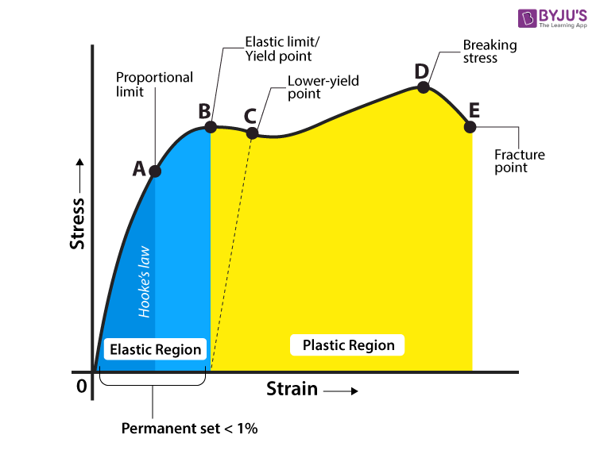

From the curve, we see that from point O to B, the region is an elastic region. After that, the plastic deformation starts. The point A in the curve shows the limit of proportionality. For this curve, we can write the value of Modulus of Elasticity (E) is equal to the slope of Stress-strain curve up to A.

If the value of E increases, then longitudinal strain decreases, that means a change in length decreases.

Here are some values of E for most commonly used materials.

* Mild steel- E= 200 GPa
* Cast iron E= 100 GPa
* Aluminium E= 200/3 GPa

### **Determination of Young’s Modulus of the Material of a Wire**

Make an experimental arrangement as shown in the figure to determine the value of Young’s modulus of a material of wire under tension.

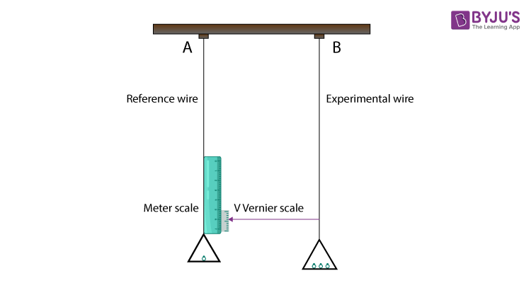

Take two identical straight wires (same length and equal radius) A and B. Now fix its end from a fixed, rigid support. The wire A is the reference wire, and it carries a millimetre main scale M and a pan to place weight. The wire B is the experimental wire. It also carries a pan in which known weights are placed. At the bottom of the wire, B attaches a vernier scale V.

Now, after putting the weight in the pan connected to B, it exerts a downward force. In the influence of this downward force (tensile Stress), wire B get stretched. This elongation (increase in length) of the wire B is measured by the vernier scale. The reference wire A is used to compensate for any change in length that may occur due to change in room temperature. Initially, give a small load to both the wires A and B so that both be straight and take the and Vernier reading. Now increase the load gradually in wire B and note the vernier reading. The difference between these two vernier readings gives the change in length produced in the wire.

Let initial radius and length of the wire B is r and L respectively,

Then the cross-sectional area of the wire would be pr2

Let M be the mass that is responsible for an elongation DL in the wire B.

Then the applied force is equal to Mg, where g is the acceleration due to gravity.

From the equation,

E= (F/A) / (DL/L)

= (F × L) / (A × DL)

The Young’s modulus of the material of the experimental wire B is given by;

Y = σ/ε

Y = (F/A)/(ΔL/L)

Y= (F × L) /(A × ΔL)

Y= (Mg × L) /(A × ΔL)

### **What are its Applications?**

* It is used in engineering as well as medical science.
* You can use the elastic modulus to calculate how much a material will stretch and also how much potential energy will be stored.
* The elastic modulus allows you to determine how a given material will respond to Stress.
* Elastic modulus is used to characterize biological materials like cartilage and bone as well

**Testing of Hardness and Impact Strength**

**HARDNESS TESTING**

Hardness represents the resistance of a material to indentation, penetration and scratching. In hardness testing, a loaded ball or diamond is pressed against the surface of a material which causes the plastic deformation of the same. This deformation is measured by one of the following methods:

**(i) Brinell Hardness test**-

In this method, a steel hardened ball is pressed into the surface of the material under a specified load. The load is held in position for a fixed period and then released. This leaves a permanent impression in the surface of the material. Then either measure the diameter or the depth of the impression.The Brinell specimen Hardness Number (BHN) is defined as the ratio of the applied load to the spherical area of the impression.

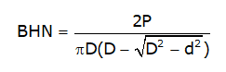

Where, P is in Newton.

Conversion tables are also available to determine the hardness number.

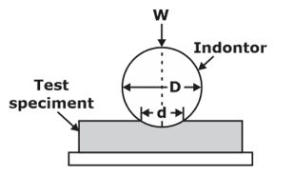

**(ii) Vicker Pyramid Diamond Method**

This method is also similar to the Brinell method except that the indenter is a 136° pyramid diamond on a square base.  As hardness of diamond is excessively high. It can be used for the whole range of materials.

The Vicker Pyramid Number (VPN) is defined as the ratio of applied load to the impressed area. The area is calculated by measuring the length of the diagonal of the square impression on the surface of the material.

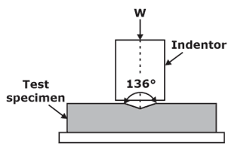

**(iii) Rockwell Hardness Method** –

The scale ranges between 0‐100. It uses either a diamond 120° cone indenter or ball indenter made of hardened steel.

Depending on the combination of indenter and load there are several Rockwell hardness scales. Three most commonly used Rockwell hardness scales are given in table.

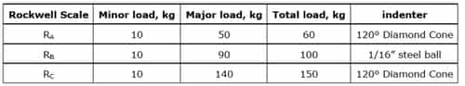

 The applied load depends on the hardness of material. As a thumb rule the load used for measuring the hardness of steel = 30D2 kg; where D is the diameter of the ball. If D = 10mm the load to be used = 3000kg.

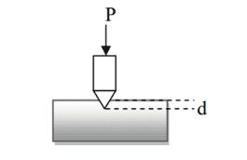

**IMPACT TESTING**

Static tests are useful only when the loads are static in nature. These tests do not indicate the resistance of a material against shock or impact loads to which usually the automobile parts are subjected to. In such cases, an impact test has to be undertaken. An impact test indicates the toughness of a material which is defined as the energy absorbed by the specimen without fracture.

The following are the main types of impact tests undertaken:

**(i) Izod Impact Test**

Figure shows an Izod impact testing machine. It consists of an anvil in which a notched specimen can be fixed. The specimen is taken of some standard dimensions. While fixing, care is to be taken to have the notch on the side of the falling hammer and the level with the level of top face of the hammer.

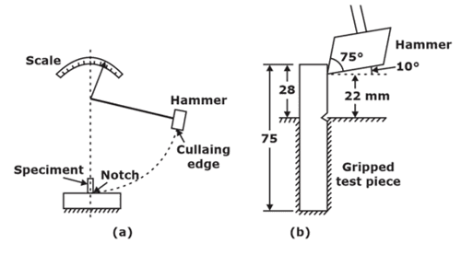

**(ii)  Charpy Impact Test**

This test is similar to the Izod impact test except that instead of fixing the notched specimen in the anvil, it is supported at each end as a beam as shown in Figure. The hammer strikes at notch in the centre. Impact tests are important as they can reveal the temper brittleness in heat treated materials such as nickel chrome steels.

